**Pre-production**

I was in charge of the UI assets, mainly combat UI. I also supervised the title screen and the stage select. I was later in charge of the attack tokens.

**Production**

I mainly focused on the battle UI, the grid that the tokens go, the atk/def button, the item box, the menu button, and the pause screen. I took careful consideration on the placement, making the grid as large as possible and buttons easily accessible. I designed it based on classic sci-fi LCD screens, although the game focused on metallic aspects, so I relied on the tokens and the top screen looking metallic. Unfortunately, the initial design was scrapped since the team members believe it’s too obstructive to the top screen, so I dramatically simplified the design.

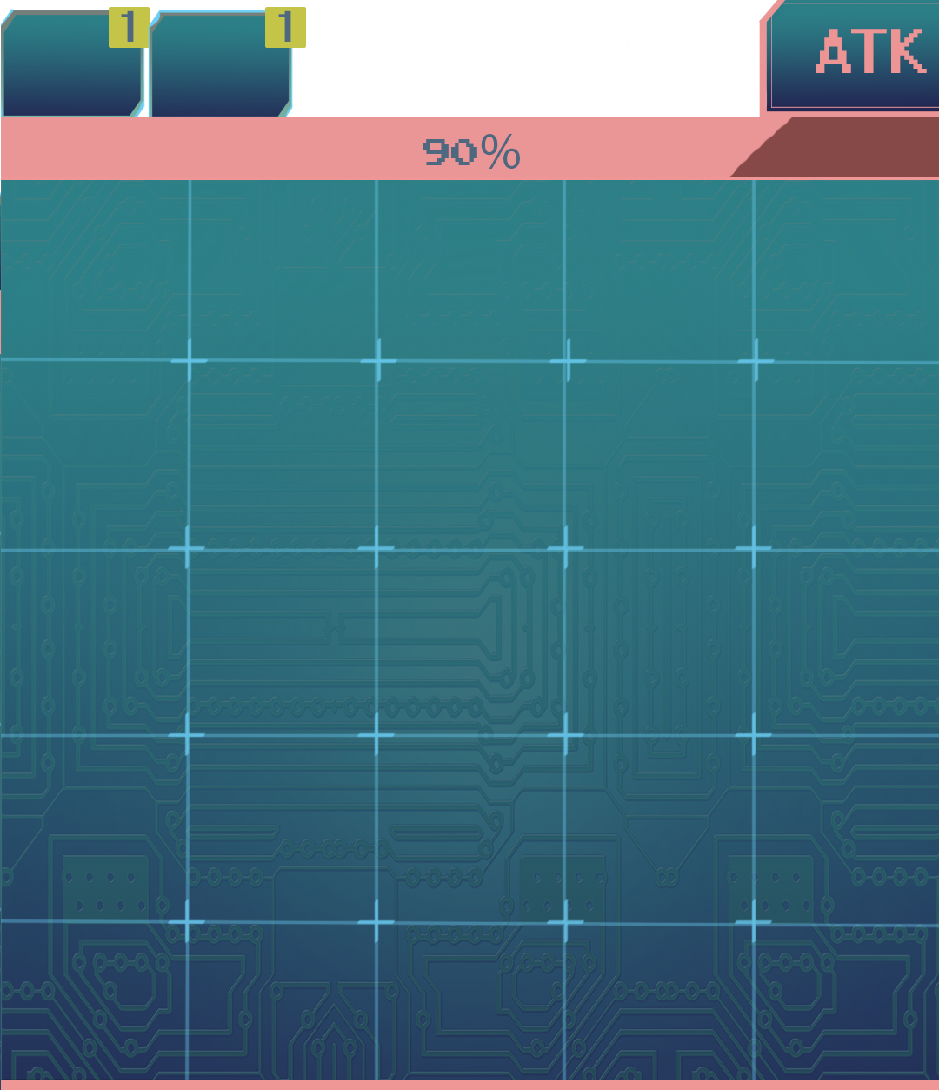

Next was the stage select. The initial stage select was too bare, so I took over the concept. My biggest obstacle was making it match to the combat UI and making it look metallic while having the necessary information. Since the items were removed, the item part of the stage select was scrapped.

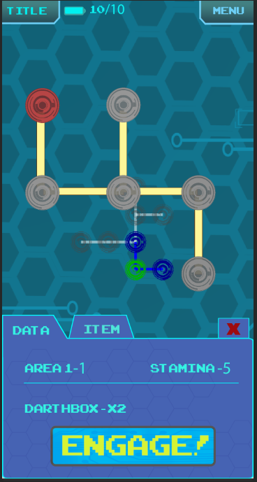

Lastly was the title screen. The logo looked plain, so I prettied it up, making it look as metallic as possible. I made the play and credits button pop out as much as possible, especially the play button.

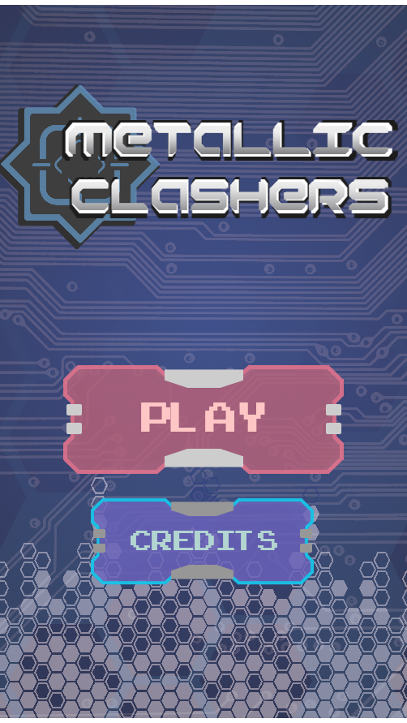

**Feedback**

Most of the feedback came from having more assets to send to the programmers and properly sending it. Every team meeting with Mr. Donald usually ended with him telling us to give them more stuff. Mr. Donald also attempted to teach me nine slicing the buttons so it’ll be easier for the programmers. I understood the concept, but for some reason it never worked for them.

**Self analysis**

The biggest wrong that happened was the sending the assets to the programs. It was so strict and specific. Almost everything I sent them, there was something wrong with it. I couldn’t get the nine slicing to work, and since the colors come out darker, I can’t send gradient colors. Actually since I couldn’t send gradients, it really destroyed many of the designs I planned. It was difficult to make something look metallic without gradient, so I made everything look LCD-like.There was also size problems (needs to be power of twos), splitting the images in different layers problem (tokens for example needed to be split and sent in different images), and some assets can’t be worked problems. Also there were communication problems. I tried my best to communicate in Slack,especially since I talk better, but it’s very frustrating when they don’t reply.

On the plus side, I was surprised how the game looked and how it actually functions.I probably could’ve made it look more metallic.

**Peer review**

Jonah Meguira - I’m glad to work with him. He’s very nice. I wish he wasn’t so sickly, though. He’s very talented in animation and 3D art, so I’m glad he took over that since I suck at it. I wish he’d use Slack more.

Brandon Pugh - He’s a very talented artist, but I do wish he’d keep within the art design that Jonah and I kept trying to drill in his head.

Brock Barlow - He’s very nice and honest. He takes the time to come in the art class to correct mistakes, so I’m glad he’s not afraid to talk in person.

Benjamin Odom - To be honest, he terrifies me. I always feel like he looks so lowly on me or think I’m an idiot. Well I feel like all three of the programmers see me that way. Other than, he’s very talented and knows a lot.

Anthony Touchet - He’s a little more comfortable to be around than the other two programmers. He also comes in a lot to help on whatever is wrong.